Activity: UML Final Project – Title & Design Proposal

- Project Title
- J-Pro Lights and Sounds Rentals: An Online Booking and Reservation System

- Problem Statement
- J-Pro Lights and Sounds Rentals currently manages bookings manually through phone calls, text messages, and written notes. This manual process is time-consuming and may lead to errors such as lost booking details, confusing schedules, and double reservations. It is also difficult for the owner to organize customer information and check event schedules.
Because of this, an online booking and reservation system is needed to make the process easier, faster, and more organized for both the owner and customers.
- Project Objectives
- To make booking easier: Replace manual booking records with an online system.
- To allow online reservations: Let customers book lights and sound services through a website.
- To organize event schedules: Help the admin manage bookings and avoid double reservations.
- To improve customer convenience: Allow customers to check available dates and reserve anytime.
- To keep booking records: Store all reservation details in one system for easy tracking.
- Target Users

- Admin (Owner): Has full access to manage the system, checks and confirms reservations, updates schedules and views booking records.

- Customers: Can create an account, log in to the system, book lights and sound services, and can view their reservation details.

- System Scope
What is included and excluded?

Included:

- User Registration and Login - Customers and admin can create accounts and log in to access the system.

- Online Booking and Reservation - Customers can reserve lights and sound services for events.
- Reservation Management by the admin - Admin can approve, update, or cancel bookings.

- Schedule Viewing - Admin can see all booked dates and events.

- Booking Records - The system saves all reservation information.

Excluded:
- Online Payment System - The system will not process payments. Customers will pay using other methods outside the system.

- Mobile Application (Web-Based System Only) - The system will only run on a website and will not have a downloadable mobile app.

- Equipment Delivery and Setup Tracking - The system will not track the delivery or setup of lights and sound equipment at event locations.
6. UML Diagram (Use Case Diagram)

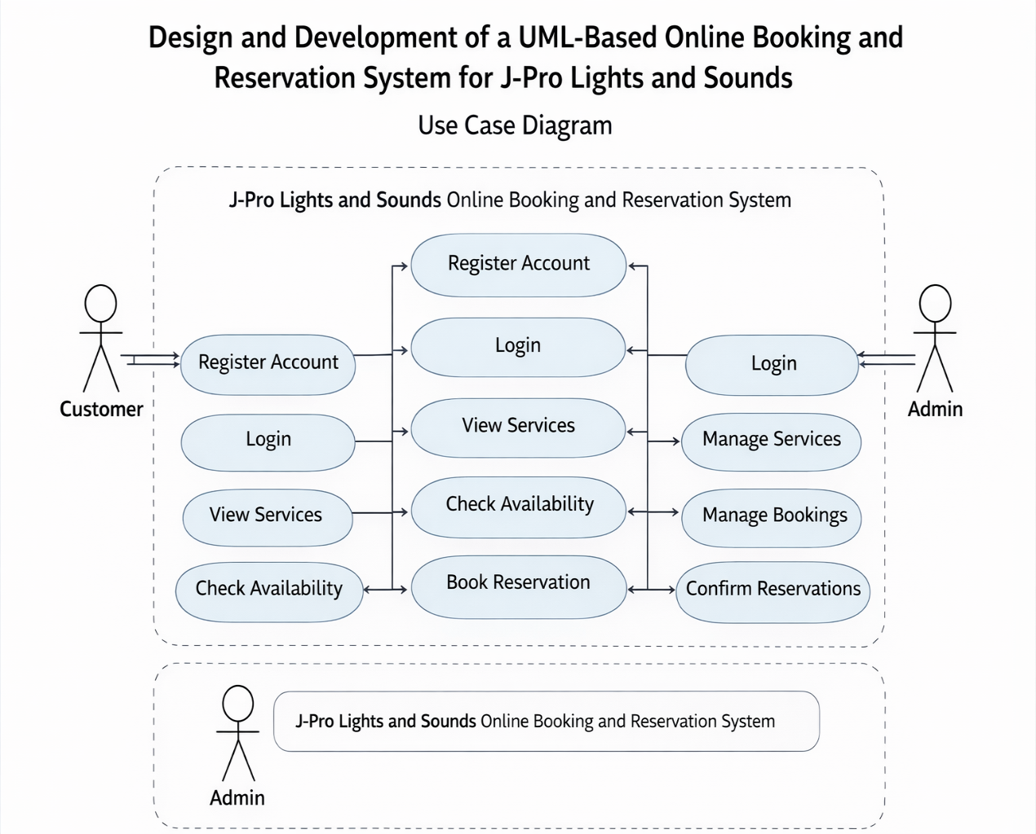
J-Pro Lights and Sounds Rentals: An Online Booking and Reservation System
J-Pro Lights and Sounds Rentals: An Online Booking and Reservation System

